FOOTPRINTING & RECONNAISSANCE ATTACKS WITH MULTIPLE KALI TOOLS

CYBERSECURITY & ETHICAL HACKING PROJECT TASK

WEEK 2 | PROJECT MODULE 1

FOOTPRINTING & RECONNAISSANCE ATTACKS WITH MULTIPLE KALI TOOLS

Background
Reconnaissance (also called as footprinting) is the first step in any real attack or security test. Before touching a target, an attacker quietly collects as much public information about it as possible. This includes who owns the domain, its real IP address, the hosting provider, the web technologies it runs, its DNS and mail records, and whether a firewall is protecting it. All of this comes from information the target has already made public, so the target never even knows it is being studied. This is why recon is powerful and very hard to detect.
What we will do in this task?
In this lab you will footprint the live website networkwalks.com using six built-in Kali Linux tools: whois, whatweb, nslookup, curl, wafw00f and dnsrecon. Each tool reveals a different piece of the target, and together they build a full profile of it. The information you gather here is the foundation for everything that follows. In the next projects/tasks you will use these same findings to plan your scanning and your attacks, because you cannot attack what you have not first understood. Record every output carefully, as you will need it for your final report.

Task 1. Run whois to find the domain registration details.
Task 2. Run whatweb to fingerprint the web technologies.
Task 3. Run nslookup to resolve the domain to its IP address.
Task 4. Run curl -I to read the HTTP response headers.
Task 5. Run wafw00f to detect a Web Application Firewall.
Task 6. Run dnsrecon to enumerate all DNS records.
Outputs
Task 1
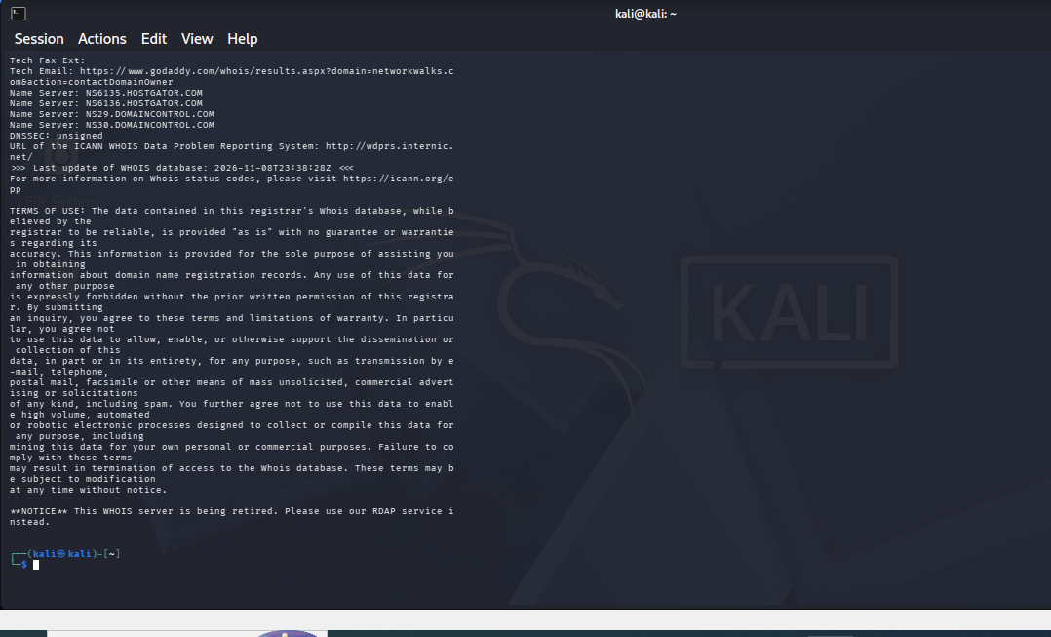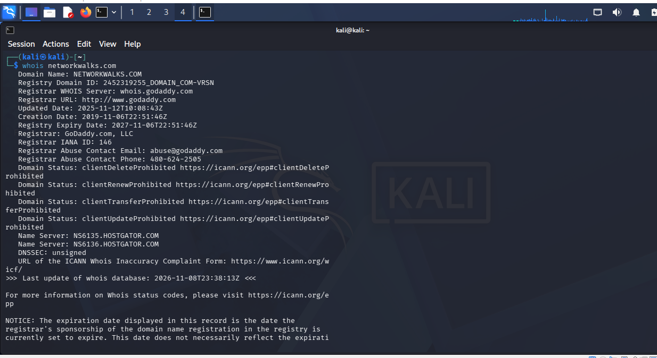

Task2
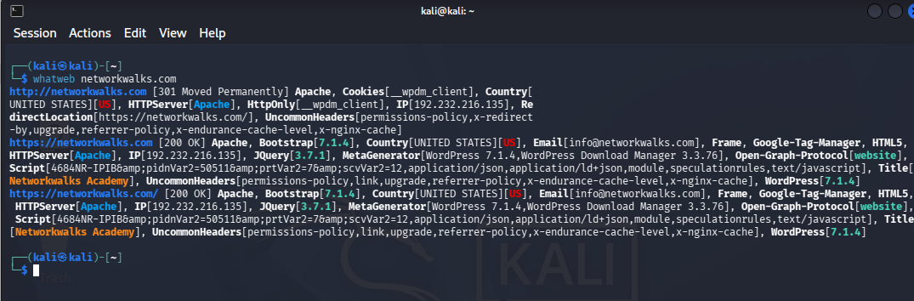
Task 3
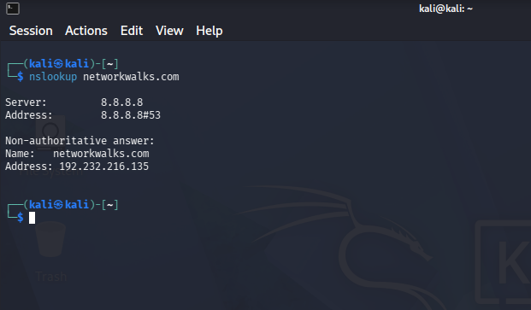
Task 4
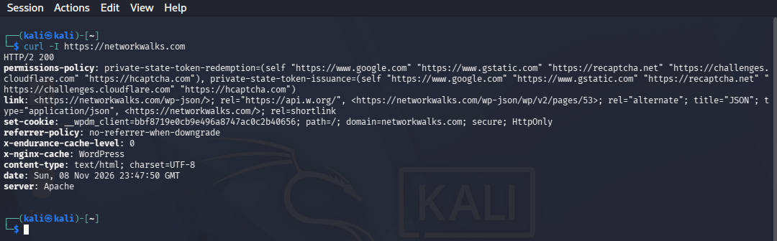
Task 5
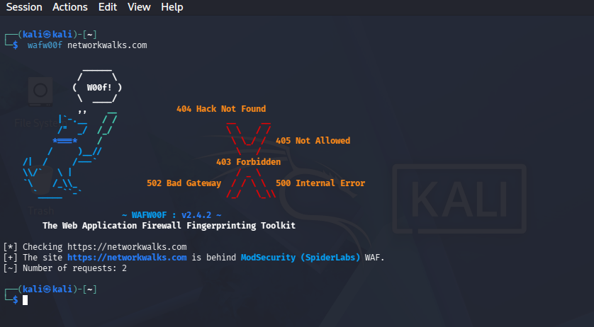
Task 6


